19CSE111
FUNDAMENTALS OF DATA STRUCTURES ASSIGNMENT-1
NAME:PALAVAJJHALA NEHA MADHU MANASA
ROLL NO:CH.EN.U4CSE22043
SECTION:CSE-A

IMPLEMENTATION OF QUEUE USING LINKED LIST
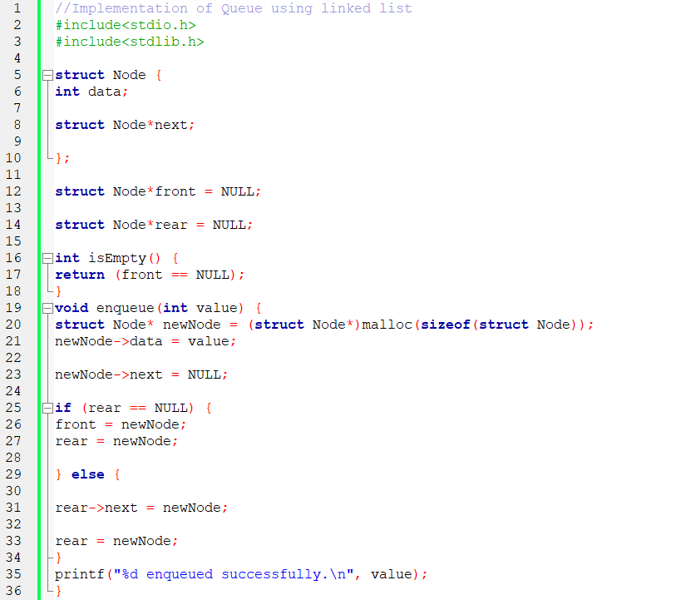

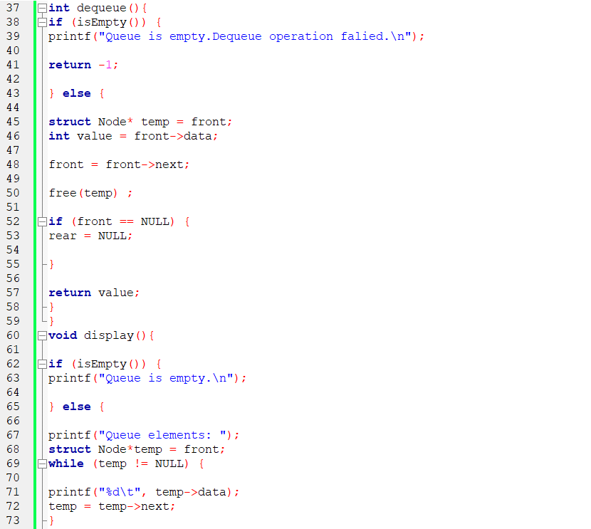
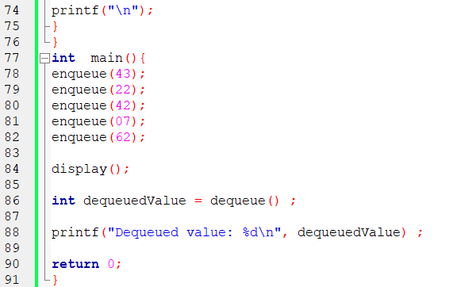
OUTPUT:
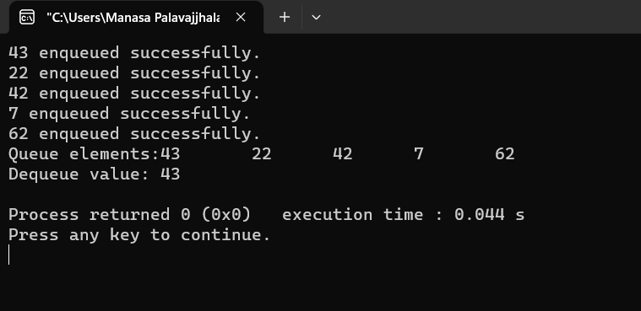

IMPLEMENTATION OF QUEUE USING ARRAY
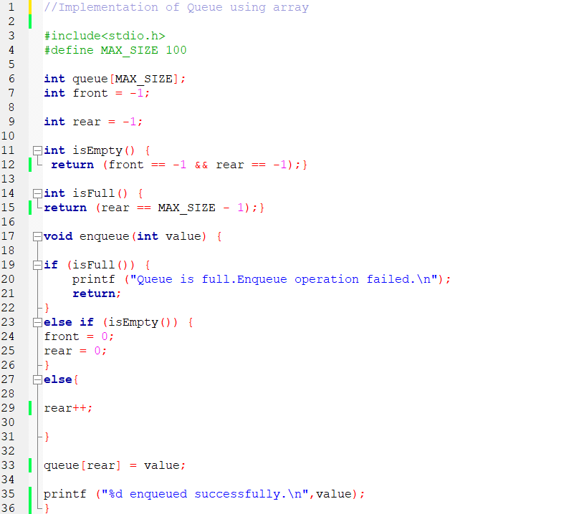

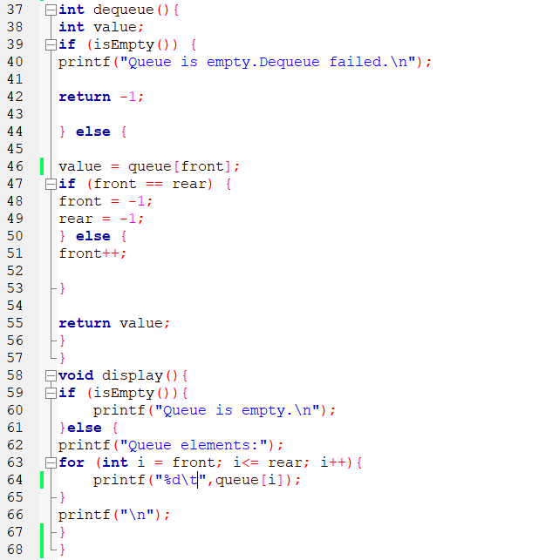

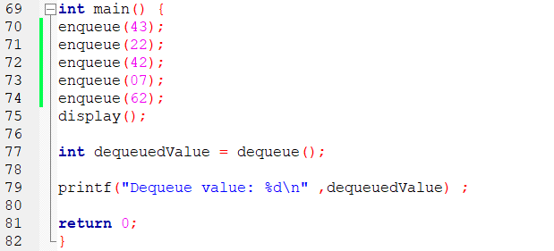
OUTPUT:

IMPLEMENTATION OF STACK USING AN ARRAY
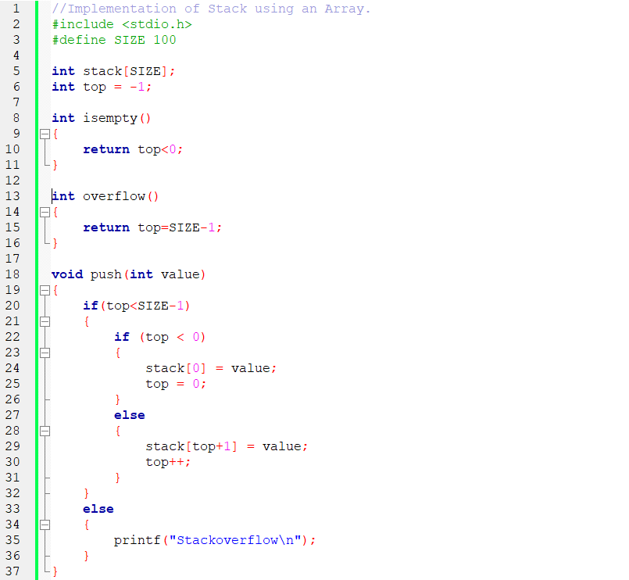

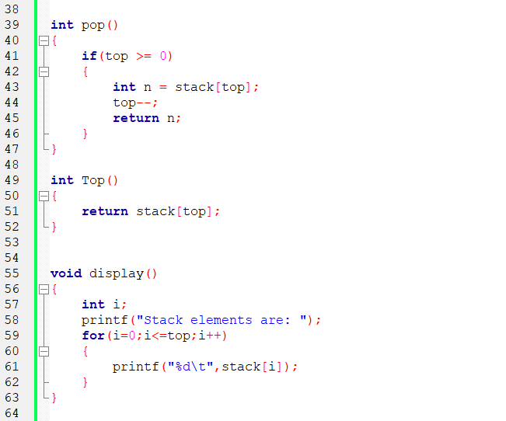
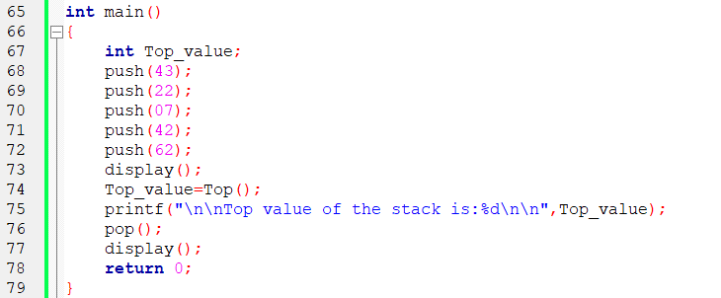
OUTPUT:
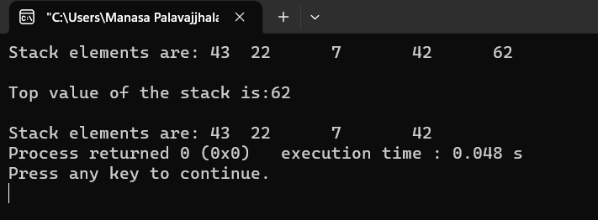
IMPLEMENTATION OF STACK USING LINKED LIST
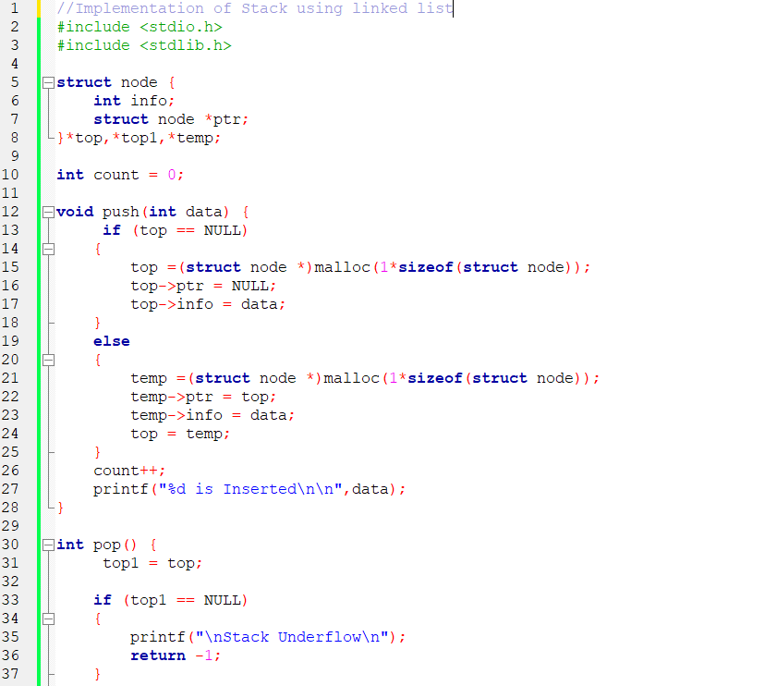

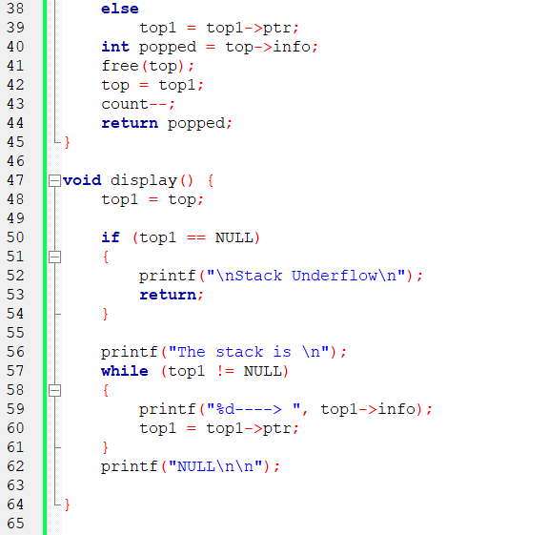
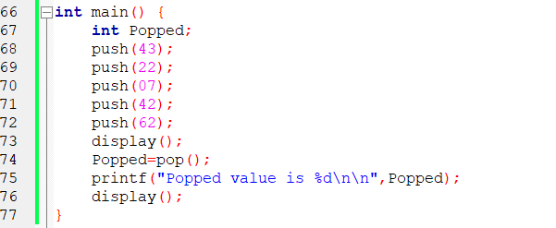
OUTPUT:
